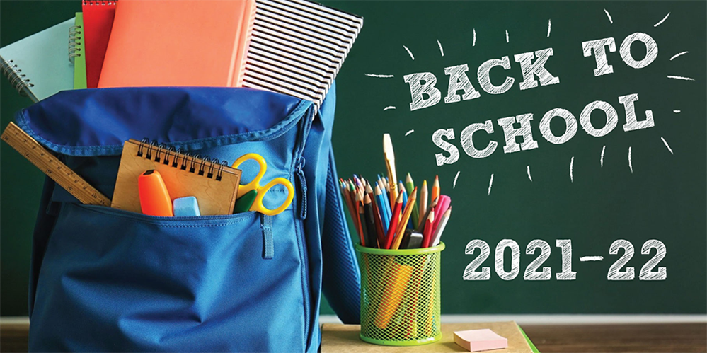

Name: ________________________________________ Date: 8/2/2021 Period: ______

- Write your preferred name or nickname.

- List a new school year resolution for 2021-2022.

- Two tales and the truth. (List one true fact and two false tales about yourself.)

- Teacher’s Choice: 1) Draw a stick picture illustration of yourself on the back of this sheet of paper. 2) Look at the image on the board. On the back of this sheet of paper, create a storyline for a movie based upon the image

