How to Log in to CommonLit using Google

CommonLit has automatically created an account for you using Google Classroom. You can now log in to your account and connect with Google Classroom. Let’s get started!

Log in to your Account:

- Go to commonlit.org/user/login and click the Log in with Google button. Enter your Google email and password.
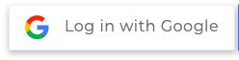
- The first time you log in, you may see a “Your Account Needs Updating” page and be prompted to select a grade level.
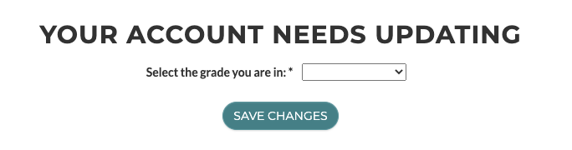
- If you are not asked to select a grade level or have already selected one, you will see the “Your Teacher Wants You to Connect to Google Classroom” page. Click the "Connect To My Google Classroom Account" button. You will not be able to access an assignment linked to Google Classroom until you connect.
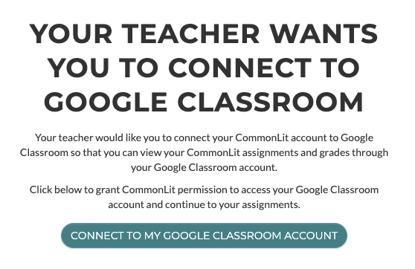
If you miss this page, don't worry - you can also connect to Google Classroom from your My Account page or before starting an assignment.

- That’s it! You are now set up and ready to start on your My Assignments page.

