Grade 8 Constructed Response Activity

Prompt
Jessie’s character says twice, “I’m Jessie.” This simple dialogue reveals Jessie to be a dynamic character.

How does the story portray Jessie as a dynamic character? Cite two details from the passage to support your answer.

Rubric
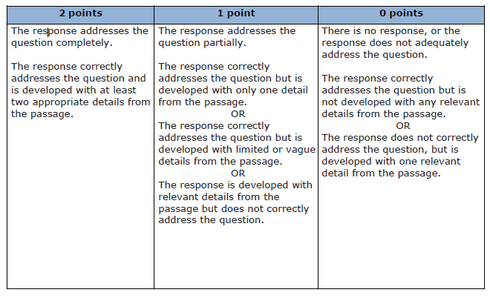

Response 1:
Jessie is a dynamic character. A dynamic character changes throughout the events of the story and she did. The story portrays her as a dynamic character by changing the way she acts after Jared left to New York. When he first meets Jessie, she is adventurous, and playful towards Jared. "I had never met anyone as adventurous as she was." When she first met him she introduced herself before helping him up. When Jared returns from New York, he was going to go see Jessie. Instead he was greeted by something entirely new. "She had on make-up, lipstick and was wearing a dress." Over the course of one summer, she had gained new friends, and a new style. She wasn't the same as before. The second time she said, "I'm Jessie," she was re-introducing herself. Helping him up, and apologizing for ignoring him. She was introducing herself again to turn a leaf, and start a new after changing after Jared had left. She had changed from just and adventurous girl he knew than, to a new best friend he would know now.

Score:

Response 2:
Jessie is a dynamic character by her being there two times to help Jared up in the story although she changed by the end she seen that she was not as happy as she was when she was friend with Jared so she apologize to Jared and told him that "she began crying she was sorry for the way she treated me that she missed me so much then they went to the creek where they went where they was littel and though mud balls at each other and was friends ever since.

Score:

Response 3:
Jessie is a dynamic character because she never changed in the story. When Jarod left and came back she was the same person as she was before.

Score:

Response 4:
The story portrays Jessie as a dynamic character because when they first met over summer they were best friends and then the second summer she was a different person. In passage two the author states," She could match me shot for shot, pitch for pitch, and mile for mile, and she was the best friend I had ever had." He was happy that she was his best friend and that they spend all his time with her until school started. Then at the end of the year Jared had to go to New York for the summer before school started back, but when he returned he went to Jessie's house and she wan't nice to him, but she came around a few weeks later after all of this happening. In passage five the author states, "She led me to the creek behind her house, and it was there that she began crying and telling me how sorry she was for the way she had treated me. She said that she was so angry with me for leaving her for the summer, and she missed me so much that she sought out other friends only to find herself caught up in the drama of being in the “cool” crowd. She apologized for hurting my feelings." He was hurt when he got pushed aside by his best friend, because he didn't expect her to treat him like this, but when she helped him up and took him to the creek he didn't know what was going on until she started apologizing to him, and then they became friends again.

Score:

Response 5:
Because she wanted to start all over. Jessie repeated herself to let her know she still care about her. Jessie wanted to start the friendship off again as it was when they first meet. In the last paragraph sixth sentence jessie says " i'm jessie as she put her arm through mine, and we walked out of the building together. That's how we know she want to restart the friendship. Jessie just didn't want her to leave without telling her that she was leaving. Friends tell each other what they are going to do and when that are going to do it.

Score:

Response 6:
Jessie is a dynamic character because of when she crashed into the girl she wasn't upset she got up and made friends with Jessie.

Score:

