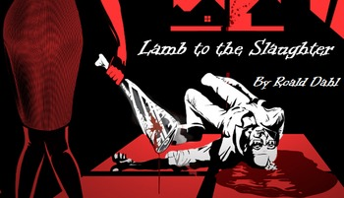

Name: ___________________________________________ Period: ________ Date: 11/12/2019
Instructions: On a separate sheet of paper, answer the following questions in PQA format. Please use textual evidence to support your responses.
“Lamb to the Slaughter” by Roald Dahl
- What is the point of view of “Lamb to the Slaughter”?
- Who is the protagonist of “Lamb to the Slaughter”?
- How does Mary welcome her husband when he arrives home?
- What’s different or odd about Patrick’s behavior when he returns home?
- What are the conflicts in the story? (Create a chart/table to present your answer.)
- Why is Patrick leaving Mary?
- What is Mary’s first reaction to the information that Patrick tells her?
- Why does Mary initially get the leg of lamb from the freezer?
- Why does Mary hit Patrick with the leg of lamb from the freezer?
- What was Mary’s initial reaction to hitting Patrick with the leg of lamb?
- How does Mary feel about the possible consequences for killing her husband?
- How does Patrick’s job benefit Mary?
- Why does Mary go to the grocery store after killing Patrick?
- How does Mary plan to get away with murdering Patrick?
- Do you think that Mary really loved Patrick? (Think about her reaction to seeing her husband lying on the floor.)
- Why do the detectives think that it’s impossible that Mary killed her husband?
- Why are the detectives and the policemen having a difficult time solving Patrick’s murder? (Hint: “It’s an old story . . . Get the weapon, and you’ve got the man.”)
- What adjustments does Mary make to her plan to help her get away with Patrick’s murder?
- What is irony?
- How does irony add humor and suspense to “Lamb to the Slaughter”?
- What are the three types of irony?
- Identify at least two examples of dramatic irony in “Lamb to the Slaughter.”
- Identify an example of situational irony in “Lamb to the Slaughter.” (Hint: Mary appears to be the perfect wife . . . or does she?)
- How does Mary change throughout the story?
- What is an inference?
- The author does not reveal if Mary gets away with the murder of her husband in the story. Instead, Dahl requires his readers to infer the resolution. What do you think happens next in the story? Please remember to support your answer with textual support.
- Bonus: Why is “Lamb to the Slaughter” an appropriate title for the story?

