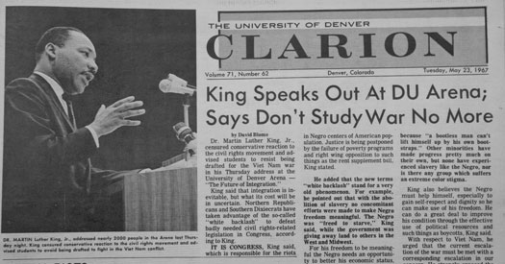
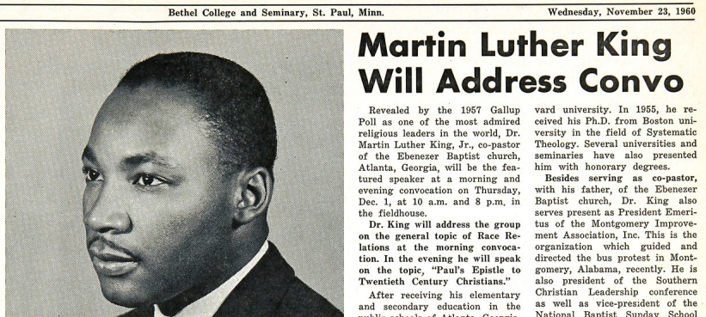

Instructions: Oberlin College was the first college in the United States to regularly admit black students. Martin Luther King Jr. visited Oberlin in 1957, shortly after the Montgomery Bus Boycott. Read the three articles about his visit and cite details to answer the After Reading questions. If you are having trouble reading the articles, a transcript of the articles is also provided for your review. Save this document with your completed answers to the After Reading questions on your One or Google Drive as MLK Primary Source Reading Activity.

Three Newspaper Articles on a 1957 Martin Luther King Speech . . .
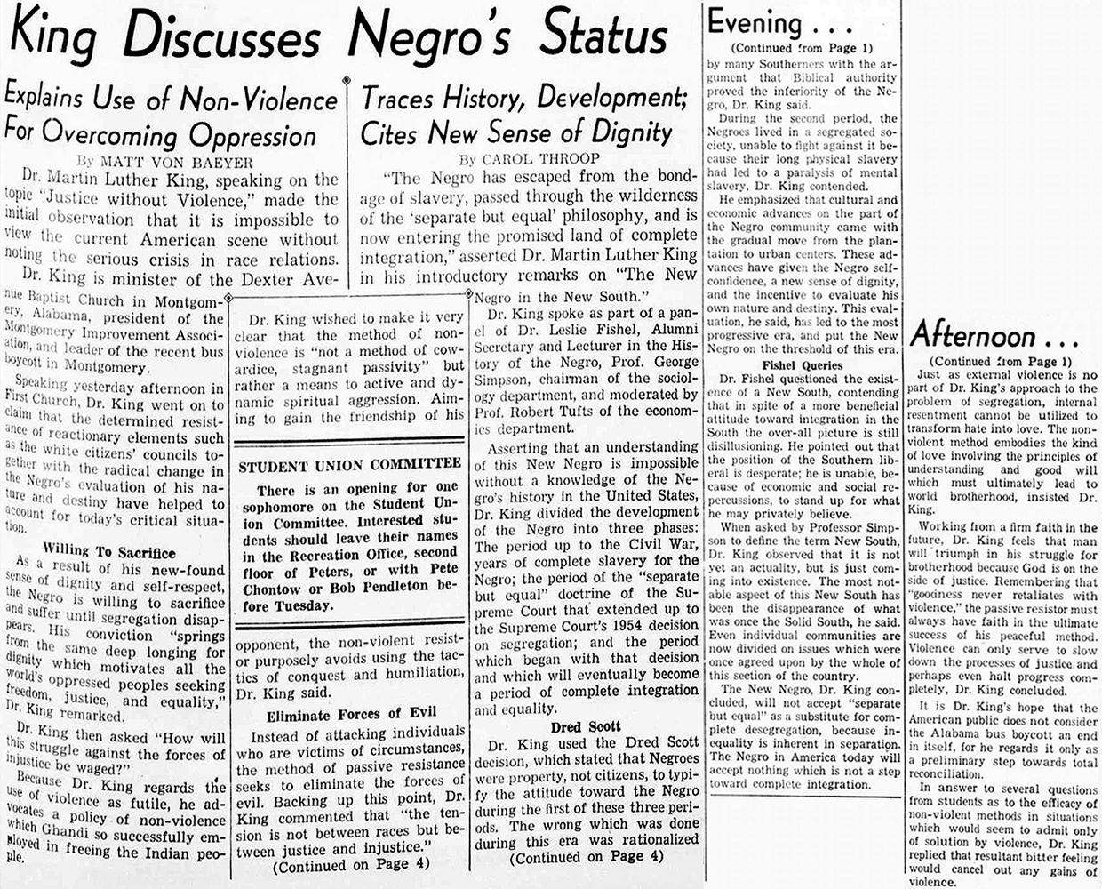
3
cont’d

HEADLINE: King Discusses Negro's Status
ARTICLE 1
TITLE: Explains Use of Non-Violence For Overcoming Oppression
by Matt Von Baeyer
TEXT:
Dr. Martin Luther King, speaking on the topic "Justice without Violence," made the initial observation that it is impossible to view the current American scene without noting the serious crisis in race relations.
Dr. King is minister of the Dexter Avenue Baptist Church in Montgomery, Alabama, president of the Montgomery Improvement Association, and leader of the recent bus boycott in Montgomery.
Speaking yesterday afternoon in First Church, Dr. King went on to claim that the determined resistance of reactionary elements such as the white citizens' councils together with the radical change in the Negro's evaluation of his nature and destiny have helped to account for today's critical situation.
As a result of his new-found sense of dignity and self-respect, the Negro is willing to sacrifice and suffer until segregation disappears. His conviction "springs from the same deep longing for dignity, which motivates al the world's oppressed peoples seeking freedom, justice, and equality," Dr. King remarked.
Dr. King then asked "How will this struggle against the forces of injustice be waged?"
Because Dr. King regards the use of violence as futile, he advocates a policy of non-violence which Gandhi so successfully employed in freeing the Indian people.
ARTICLE 2
TITLE: Martin Luther King's Afternoon Lecture
by Matt Von Baeyer
TEXT:
Dr. King wished to make it very clear that the method of no-violence is "not a method of cowardice, stagnant passivity" but rather a means to active and dynamic spiritual aggression. Aiming to gain the friendship of his opponent, the non-violent resistor purposely avoids using the tactics of conquest and humiliation, Dr. King said.
Eliminate Forces of Evil
Instead of attacking individuals who are victims of circumstances, the method of passive resistance seeks to eliminate the forces of evil. Backing up this point, Dr. King commented that “the tension is not between races but between justice and injustice.”
Just as external violence is no part of Dr. King's approach to the problem of segregation, internal resentment cannot be utilized to transform hate into love. The non-violent method embodies the kind of love involving the principles of understanding and good will which must ultimately lead to world brotherhood, insisted Dr. King.
Working from a firm faith in the future, Dr. King feels that man will triumph in his struggle for brotherhood because God is on the side of justice. Remembering that "goodness never retaliates with violence," the passive resistor must always have faith in the ultimate success of his peaceful method. Violence can only serve to slow down the processes of justice and perhaps even halt progress completely, Dr. King concluded.
It is Dr. King’s hope that the American public does not consider the Alabama boycott an end in itself, for he regards it only as a preliminary step towards total reconciliation.
In answer to several questions from students as to the efficacy of non-violent methods in situations which would seem to admit only of solution by violence, Dr. King replied that resultant bitter feeling would cancel out any gains of violence.
ARTICLE 3
TITLE: Traces History, Development; Cites New Sense of Dignity
By Carol Throop
TEXT:
"The Negro has escaped from the bondage of slavery, passed through the wilderness of the 'separate but equal' philosophy, and is now entering the promised land of complete integration," asserted Dr. Martin Luther King in his introductory remarks on "The New Negro in the New South."
Dr. King spoke as part of a panel of Dr. Leslie Fishel, Alumni Secretary and Lecturer in the History of the Negro, Prof. George Simpson, chairman of the sociology department, and moderated by Prof. Robert Tufts of the economics department, Alumni Secretary and Lecturer in the History of the Negro, Prof. George Simpson, chairman of the sociology department, and moderated by Prof. Robert Tufts of the economics department.
Asserting that an understanding of this New Negro is impossible without a knowledge of the Negro's history in the United States, Dr. King divided the development of the Negro into three phases: The period up to the Civil War, years of complete slavery for the Negro; the period of the "separate but equal" doctrine of the Supreme Court that extended up to the Supreme Court's 1954 decision on segregation; and the period which began with that decision and which will eventually become a period of complete integration and equality.
Dred Scott
Dr. King used the Dred Scott decision, which stated that Negroes were property, not citizens, to typify the attitude toward the Negro during the first of these three periods. The wrong which was done during this era was rationalized by many Southerners with the argument that Biblical authority proved the inferiority of the Negro, Dr. King said.
During the second period, the Negroes lived in a segregated society, unable to fight against it because their long physical slavery had led to a paralysis of mental slavery, Dr. King contended.
He emphasized that cultural and economic advances on the part of the Negro community came with the gradual move from the planation to urban centers. These advances have given the Negro self-confidence, a new sense of dignity, and the incentive to evaluate his own nature and destiny. This evaluation, he said, has led to the most progressive era, and put the New Negro on the threshold of this era.
Fishel Queries
Dr. Fishel questioned the existence of a New South, contending that in spite of a more beneficial attitude toward integration in the South the over-all picture is still disillusioning. He pointed out that the position of the Southern liberal is desperate; he is unable, because of economic and social repercussions, to stand up for what he may privately believe.
When asked by Professor Simpson to define the term New South, Dr. King observed that it is not yet an actuality, but is just coming into existence. The most notable aspect of this New South has ben the disappearance of what was once the Solid South, he said. Even individual communities are now divided on issues which were once agreed upon by the whole of this section of the country.
The New Negro, Dr. King concluded, will not accept "separate but equal" as a substitute for complete desegregation, because inequality is inherent in separation. The Negro in America today will accept nothing which is not a step toward complete integration.

The Oberlin Review, Oberlin, Ohio. February 8, 1957.

After Reading
Use textual evidence from the three primary source articles to answer the following questions:
- How did Dr. King defend non-violent resistance? To what critics might he have been responding?

- Explain Dr. King’s reasoning for rejecting violent resistance.

- According to King, what distinguished African-Americans of the civil rights era from those of earlier periods in American history?

- Name one modern protest movement Dr. King would be likely to support. Explain your reasoning.

