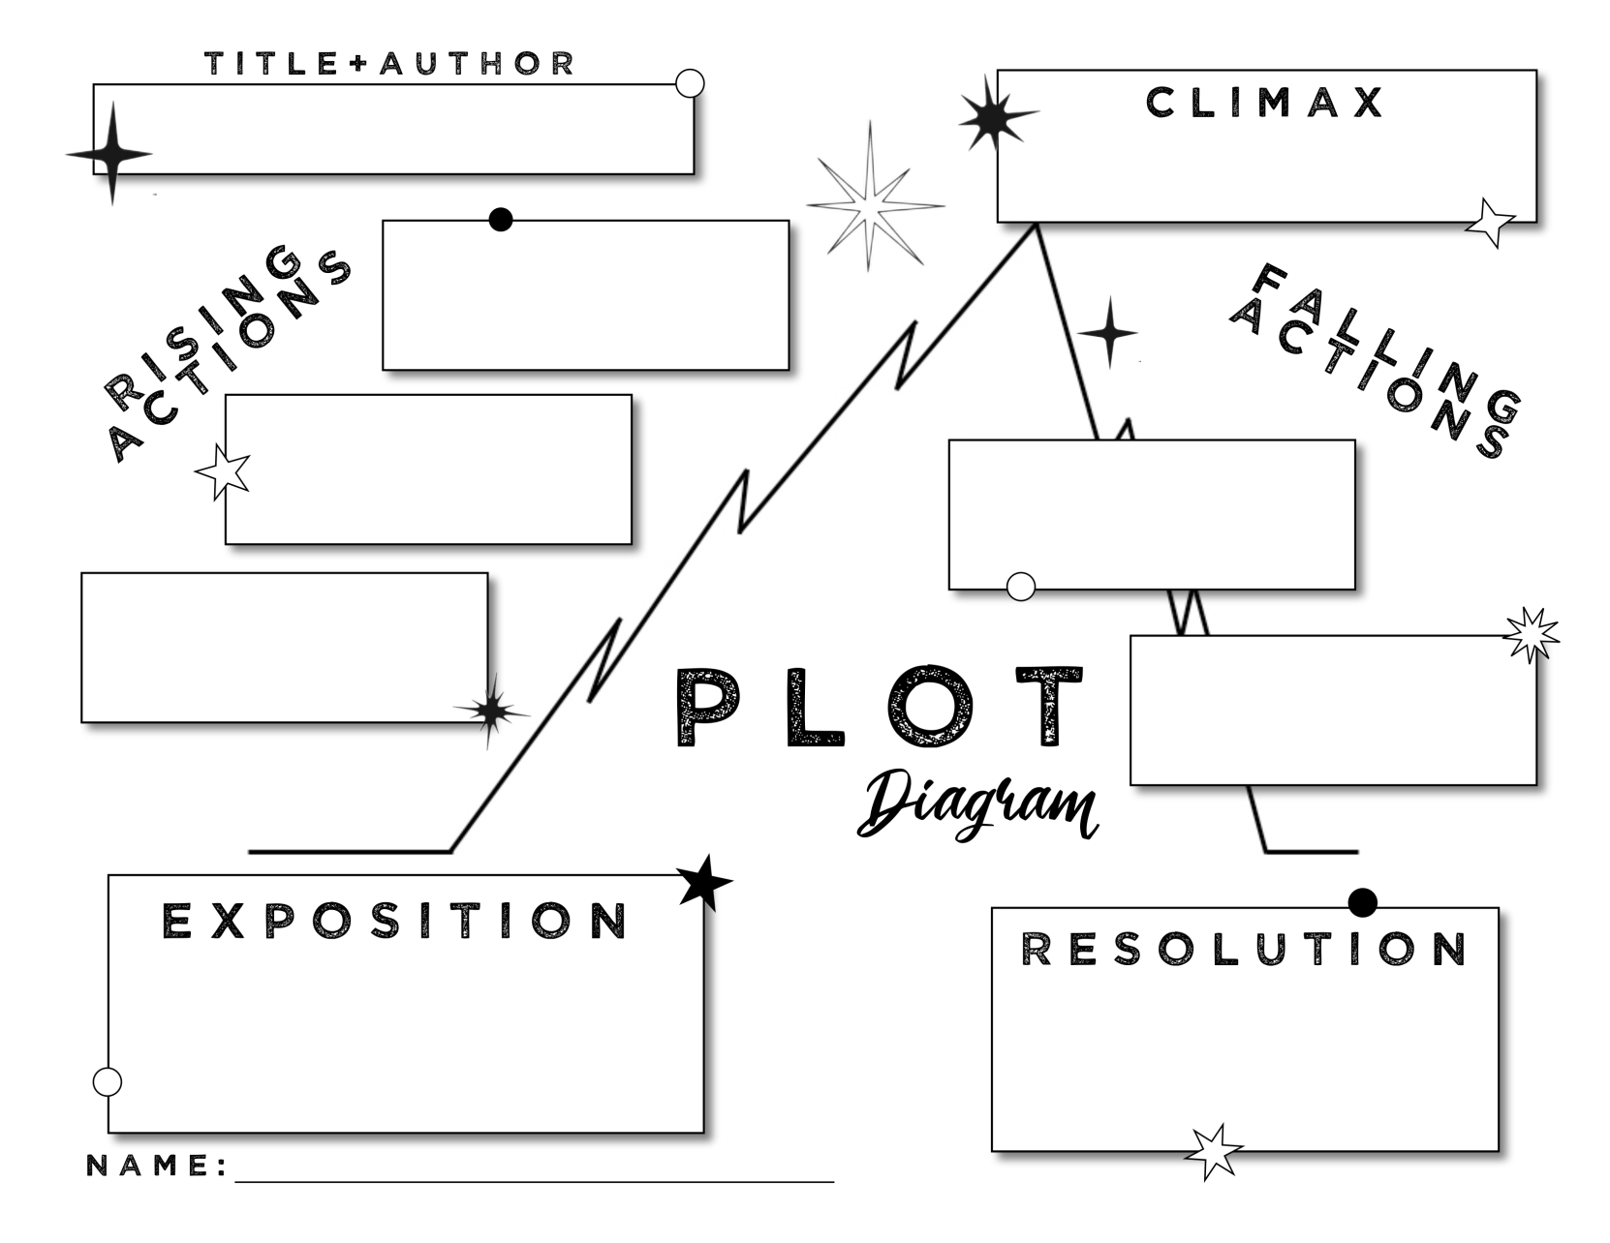

Type to enter text

Type to enter text

Type to enter text

Type to enter text

Type to enter text

Type to enter text

Type to enter text

Type to enter text

Type to enter text

Type to enter text