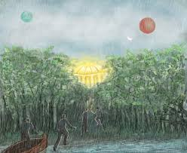
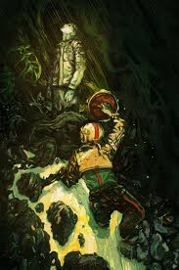
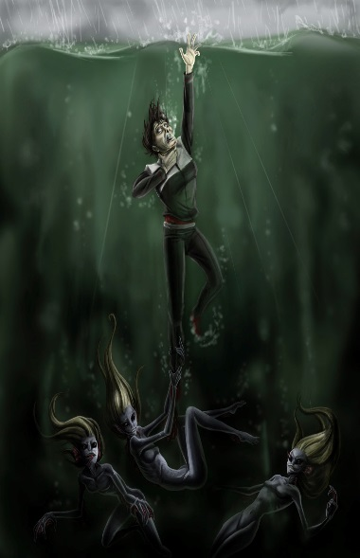
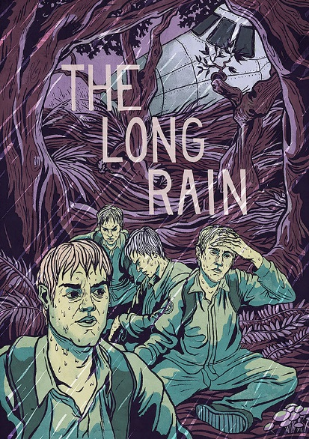

“The Long Rain” Discussion Questions
By Ray Bradbury

1. What is the setting of the story? How does this create a complication for the characters? What analogies/comparisons does Bradbury use to help his readers understand and visualize the complexities of this setting?
2. Identify the protagonist(s) and the antagonist(s) of “The Long Rain.”
3. What is a thematic message in “The Long Rain”?
4. Are there multiple themes in “The Long Rain”? What other thematic messages can you identify? (Remember to provide textual support to validate your responses.)
5. Some of the survivors from the rocket crash die in unique ways. How do their deaths reinforce the/a theme of/in the story?
6. Create a graphic organizer that lists the conflicts in the story. Please create columns that specify the type of conflict, and quotes that support your identifications.
7. How have the people of Venus tried to adapt to a rainy climate? Even with these adaptations, what effect do you think the constant rain would have on people? Explain your answer.
8. The characters in this story all have different reactions to their circumstances. What do their different reactions tell us about them? What do their reactions say about human nature?
9. While the story seems to end with the lieutenant finding an intact and inhabited Sun Dome, there is doubt that this happened; he could simply have gone mad and hallucinated the ending.
- Find two quotes that support each side of the argument, and explain how they do.
- What do you think happens at the end of the story? Explain.
10. Why do you think Bradbury left the ending indeterminate?
11. Explain what the following ideas symbolize in the story:
- The Sun Dome
- The color of the jungle
- The rain

12. Identify the mood of the story.
13. In the story, identify examples of the various imagery techniques (appeal to the 5 senses, details, strong diction, and figurative language). Locate as many examples as you can.
14. What do you think Ray Bradbury is saying about hope? Explain your answer.
15. What warning(s) do you think Bradbury is giving his readers through the composition of this story?

