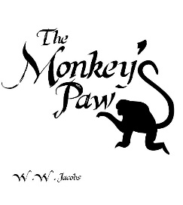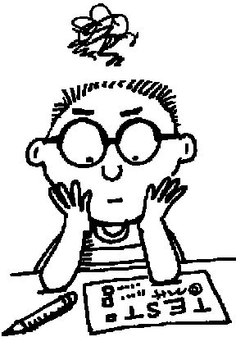

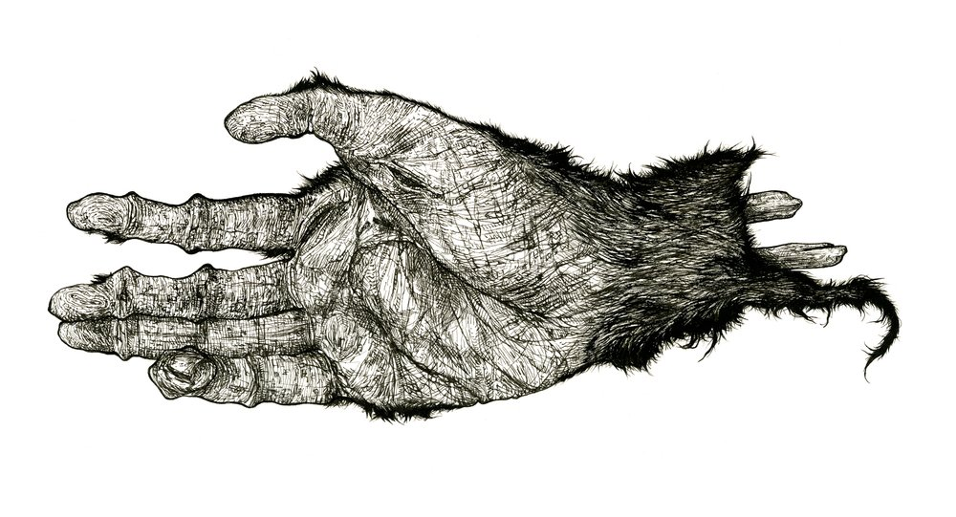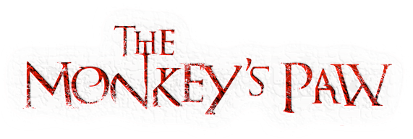

**Instructions**: Please answer all applicable questions on a separate sheet of paper in PQA format (Put the Question in your answer). Use textual evidence from the story to support all responses. (***Note***: You may also complete this assignment using Word Online/Google Docs. Be prepared to submit a link to your work on your period’s Google Class Doc.)

**Chapter 1 Questions:**

1. What is the **setting** of the story? (Hint: MLL pg. 360, lines 1-18)
2. How does Mr. White approach the game of chess as he plays with his son? (What might this reveal about his personality/character traits?)
3. What is the **mood** in the beginning of the story? (Hint: Ensure that you understand the definition for mood. Next, analyze the words and phrases that describe the setting. Reflect on the feelings that the words/phrases suggest/evoke.)
4. What is the denotation of **foreshadowing**?
5. When Mr. White states that he’d like to go to India, just like Sergeant-Major Morris, Morris tells him “Better where you are.” In what way might this be **foreshadowing**?
6. Morris tells Mr. White that the old fakir who owned the monkey’s paw put a spell on it to “show that fate ruled people’s lives, and that those who interfered with it did so to their sorrow.” How might this information about the monkey’s paw be an example of **foreshadowing**?
7. What power does the paw have?
8. What is the sergeant-major’s attitude toward the paw?
9. After Mr. White retrieves the monkey’s paw from the fire, give examples of **foreshadowing** clues, provided by Morris, that build **suspense** or hint at what might happen later in connection with the monkey’s paw.
10. In chapter one, what attitude do the Whites have toward the paw? (Include examples of Mr. White, Mrs. White, and Herbert White’s attitude towards the monkey’s paw.)
11. Why does Mr. White at first have trouble making a wish on the monkey’s paw? What does he end up wishing for?
12. What happens when Mr. White uses the paw to make his wish?
13. **4th period only:** In the beginning (on the very first page), the **mood** of the story alternates between light and dark. Create a graphic organizer and Identify light and dark passages throughout the story. Note specific details to support your listing.
14. Reread lines 146-150. How does this passage reveal that Herbert is fighting a **superstitious** feeling about the monkey’s paw?

**Chapter 2 Questions:**

1. Create a **graphic organizer** that presents each of the White’s attitude about the power of the monkey’s paw in chapter two. You should have a minimum of three columns (character’s name, the family member’s attitude the power of the monkey’s paw, textual evidence to support your answer). *Hint*: Lines 156-190
2. What example(s) of **foreshadowing** can you identify in lines 156-161? (MLL pg. 366)
3. Using details from the first page of chapter two, provide examples of Mrs. White’s contradictory feelings about the monkey’s paw and the wish that Mr. White made.
4. When the well-dressed stranger appears at their home, what **foreshadowing** clues are provided that hint at the message that he brings will not be a positive one? *Hint*: Lines 186-229
5. What is an **inference**?
6. When the stranger arrives, what clues can the reader use to make an **inference** that Mrs. White believes he is rich? What inference can the reader make about why Mrs. White believes the stranger has come?
7. What does the stranger tell Mr. and Mrs. White?
8. How was Mrs. White able to make the **inference** that her son was dead? (MLL pg. 367, line 204 references the “sinister meaning” of the information the stranger brings.
9. Mr. White does not faint when he is given the news of his son’s death. Why does he faint when he hears that the compensation is 200 pounds?
10. How is the end of chapter two an example of **situational irony**?

**Chapter 3 Questions:**

1. In what ways has Mrs. White’s attitude about the power of the monkey’s paw changed? (Does Mrs. White still think that the paw is just a superstitious belief? Reread lines 248-260.)
2. Why might Mr. White say that to bring back their son would be “foolish and wicked”?
3. What is the White’s second wish with the monkey’s paw?
4. Make an inference as to what Mr. White believes is on the other side of the door. (Think about how Mr. White reacts when he hears the knocks at the door? Line 288, MLL pg. 370)
5. Why do you think Mr. White is afraid of what might be on the other side of the door? (Hint: ““Don’t let it in,” cried the old man, trembling.”)
6. Why does Mr. White want to find the monkey’s paw?
7. Make an **inference**: What is Mr. White’s “third and last wish”?
8. Make an inference: At the end of the story, why did the knocking stop so suddenly? Explain. (*Note*: You may skip this question if you know the answer.)
9. With all of the story’s events in mind, why do you think Mr. White made a third wish?